PRESERVE.
SET DECIMAL DOT.

GET DATA /TYPE=TXT
/FILE="C:\Users\Grace Kyendo\Desktop\Life Expectancy Data.csv"
/ENCODING='UTF8'
/DELIMITERS=","
/QUALIFIER='"'
/ARRANGEMENT=DELIMITED
/FIRSTCASE=2
/DATATYPEMIN PERCENTAGE=95.0
/VARIABLES=
Country AUTO
Year AUTO
Status AUTO
Lifeexpectancy AUTO
AdultMortality AUTO
infantdeaths AUTO
Alcohol AUTO
percentageexpenditure AUTO
HepatitisB AUTO
Measles AUTO
BMI AUTO
underfivedeaths AUTO
Polio AUTO
Totalexpenditure AUTO
Diphtheria AUTO
HIVAIDS AUTO
GDP AUTO
Population AUTO
thinness119years AUTO
thinness59years AUTO
Incomecompositionofresources AUTO
Schooling AUTO
/MAP.

Error. Command name: GET DATA
(2269) Failure opening file: C:\Users\Grace Kyendo\Desktop\Life Expectancy Data.csv
Execution of this command stops.
RESTORE.
CACHE.
EXECUTE.

Error # 105. Command name: EXECUTE
This command is not valid before a working file has been defined.
Execution of this command stops.
DATASET NAME DataSet1 WINDOW=FRONT.

GET DATA
/TYPE=XLSX
/FILE='C:\Users\Grace Kyendo\Desktop\Simulation & Modeling\Life Expectancy Data.xlsx'
/SHEET=name 'Life Expectancy Data'
/CELLRANGE=FULL
/READNAMES=ON
/DATATYPEMIN PERCENTAGE=95.0
/HIDDEN IGNORE=YES.
EXECUTE.
DATASET NAME DataSet2 WINDOW=FRONT.

SAVE OUTFILE='C:\Users\Grace Kyendo\Desktop\Simulation & Modeling\CM_SM_QN2.sav'
/COMPRESSED.
DATASET ACTIVATE DataSet2.
DATASET CLOSE DataSet1.
FILTER OFF.
USE ALL.
SELECT IF (NOT(SYSMIS(Year) OR SYSMIS(Lifeexpectancy) OR SYSMIS(AdultMortality) OR
SYSMIS(infantdeaths) OR SYSMIS(Alcohol) OR SYSMIS(percentageexpenditure) OR SYSMIS(HepatitisB)
OR SYSMIS(Measles) OR SYSMIS(BMI) OR SYSMIS(underfivedeaths) OR SYSMIS(Polio) OR
SYSMIS(Totalexpenditure) OR SYSMIS(Diphtheria) OR SYSMIS(HIVAIDS) OR SYSMIS(GDP) OR
SYSMIS(Population) OR SYSMIS(thinness119years) OR SYSMIS(thinness59years) OR
SYSMIS(Incomecompositionofresources) OR SYSMIS(Schooling) )).
EXECUTE.
* Visual Binning.
*GDP.
RECODE GDP (MISSING=COPY) (LO THRU 1.5=1) (LO THRU 11918.594=2) (LO THRU 23835.688=3) (LO THRU
35752.782=4) (LO THRU 47669.876=5) (LO THRU 59586.9700000000=6) (LO THRU 71504.064=7) (LO THRU
83421.158=8) (LO THRU 95338.252=9) (LO THRU 107255.346=10) (LO THRU HI=11) (ELSE=SYSMIS) INTO
GDPGROUPED.
VARIABLE LABELS GDPGROUPED 'GDP (Binned)'.
FORMATS GDPGROUPED (F5.0).
VALUE LABELS GDPGROUPED 1 '' 2 '' 3 '' 4 '' 5 '' 6 '' 7 '' 8 '' 9 '' 10 '' 11 ''.
VARIABLE LEVEL GDPGROUPED (ORDINAL).
EXECUTE.
GLM Lifeexpectancy AdultMortality BY GDPGROUPED Status
/METHOD=SSTYPE(3)
/INTERCEPT=INCLUDE
/SAVE=PRED ZRESID
/PLOT=PROFILE(GDPGROUPED Status) TYPE=LINE ERRORBAR=NO MEANREFERENCE=NO YAXIS=AUTO
/EMMEANS=TABLES(OVERALL)
/EMMEANS=TABLES(GDPGROUPED)
/EMMEANS=TABLES(Status)
/EMMEANS=TABLES(GDPGROUPED*Status)
/CRITERIA=ALPHA(.05)
/DESIGN= GDPGROUPED Status GDPGROUPED*Status.

General Linear Model

Notes
Output Created |  | 07-SEP-2024 22:10:47
Comments
Input | Data | C:\Users\Grace Kyendo\Desktop\Simulation & Modeling\CM_SM_QN2.sav
Input | Active Dataset | DataSet2
Input | Filter | <none>
Input | Weight | <none>
Input | Split File | <none>
Input | N of Rows in Working Data File | 1649
Missing Value Handling | Definition of Missing | User-defined missing values are treated as missing.
Missing Value Handling | Cases Used | Statistics are based on all cases with valid data for all variables in the model.
Syntax |  | GLM Lifeexpectancy AdultMortality BY GDPGROUPED Status  /METHOD=SSTYPE(3)  /INTERCEPT=INCLUDE  /SAVE=PRED ZRESID  /PLOT=PROFILE(GDPGROUPED Status) TYPE=LINE ERRORBAR=NO MEANREFERENCE=NO YAXIS=AUTO  /EMMEANS=TABLES(OVERALL)  /EMMEANS=TABLES(GDPGROUPED)  /EMMEANS=TABLES(Status)  /EMMEANS=TABLES(GDPGROUPED*Status)  /CRITERIA=ALPHA(.05)  /DESIGN= GDPGROUPED Status GDPGROUPED*Status.
Resources | Processor Time | 00:00:03.06
Resources | Elapsed Time | 00:00:02.57
Variables Created or Modified | PRE_1 | Predicted Value for Lifeexpectancy
Variables Created or Modified | PRE_2 | Predicted Value for AdultMortality
Variables Created or Modified | ZRE_1 | Standardized Residual for Lifeexpectancy
Variables Created or Modified | ZRE_2 | Standardized Residual for AdultMortality

Between-Subjects Factors
 |  | Value Label | N
GDP (Binned) | 2 | 2 | 1452
GDP (Binned) | 3 | 3 | 99
GDP (Binned) | 4 | 4 | 38
GDP (Binned) | 5 | 5 | 30
GDP (Binned) | 6 | 6 | 18
GDP (Binned) | 7 | 7 | 6
GDP (Binned) | 8 | 8 | 1
GDP (Binned) | 9 | 9 | 1
GDP (Binned) | 11 | 11 | 4
Status | 1 | Developing | 1407
Status | 2 | Developed | 242

Multivariate Testsª
Effect |  | Value | F | Hypothesis df | Error df
Intercept | Pillai's Trace | .849 | 4602.467^{b} | 2.000 | 1634.000
Intercept | Wilks' Lambda | .151 | 4602.467^{b} | 2.000 | 1634.000
Intercept | Hotelling's Trace | 5.633 | 4602.467^{b} | 2.000 | 1634.000
Intercept | Roy's Largest Root | 5.633 | 4602.467^{b} | 2.000 | 1634.000
GDPGROUPED | Pillai's Trace | .069 | 7.324 | 16.000 | 3270.000
GDPGROUPED | Wilks' Lambda | .931 | 7.454^{b} | 16.000 | 3268.000
GDPGROUPED | Hotelling's Trace | .074 | 7.584 | 16.000 | 3266.000
GDPGROUPED | Roy's Largest Root | .074 | 15.150^{c} | 8.000 | 1635.000
Status | Pillai's Trace | .001 | 1.174^{b} | 2.000 | 1634.000
Status | Wilks' Lambda | .999 | 1.174^{b} | 2.000 | 1634.000
Status | Hotelling's Trace | .001 | 1.174^{b} | 2.000 | 1634.000
Status | Roy's Largest Root | .001 | 1.174^{b} | 2.000 | 1634.000
GDPGROUPED * Status | Pillai's Trace | .036 | 7.416 | 8.000 | 3270.000
GDPGROUPED * Status | Wilks' Lambda | .964 | 7.477^{b} | 8.000 | 3268.000
GDPGROUPED * Status | Hotelling's Trace | .037 | 7.537 | 8.000 | 3266.000
GDPGROUPED * Status | Roy's Largest Root | .036 | 14.907^{c} | 4.000 | 1635.000

Tests of Between-Subjects Effects
Source | Dependent Variable | Type III Sum of Squares | df | Mean Square | F
Corrected Model | Life expectancy | 35587.767ª | 13 | 2737.521 | 48.681
Corrected Model | Adult Mortality | 2638846.850^{b} | 13 | 202988.219 | 14.281
Intercept | Life expectancy | 264079.808 | 1 | 264079.808 | 4696.141
Intercept | Adult Mortality | 312005.850 | 1 | 312005.850 | 21.951
GDPGROUPED | Life expectancy | 6573.037 | 8 | 821.630 | 14.611
GDPGROUPED | Adult Mortality | 453497.298 | 8 | 56687.162 | 3.988
Status | Life expectancy | 124.440 | 1 | 124.440 | 2.213
Status | Adult Mortality | 22754.818 | 1 | 22754.818 | 1.601
GDPGROUPED * Status | Life expectancy | 3046.657 | 4 | 761.664 | 13.545
GDPGROUPED * Status | Adult Mortality | 148245.820 | 4 | 37061.455 | 2.607
Error | Life expectancy | 91941.544 | 1635 | 56.233
Error | Adult Mortality | 23239203.725 | 1635 | 14213.580
Total | Life expectancy | 8047362.010 | 1649
Total | Adult Mortality | 72538783.000 | 1649
Corrected Total | Life expectancy | 127529.311 | 1648
Corrected Total | Adult Mortality | 25878050.575 | 1648

Estimated Marginal Means

1. Grand Mean
Dependent Variable | Mean | Std. Error | 95% Confidence Interval
Dependent Variable | Mean | Std. Error | Lower Bound | Upper Bound
Life expectancy | 79.424ª | .971 | 77.520 | 81.328
Adult Mortality | 82.977ª | 15.435 | 52.703 | 113.251

a. Based on modified population marginal mean.

2. GDP (Binned)
Dependent Variable | GDP (Binned) | Mean | Std. Error | 95% Confidence Interval
 |  |  |  | Lower Bound | Upper Bound
Life expectancy | 2 | 72.261 | .355 | 71.566 | 72.957
Life expectancy | 3 | 76.948 | .754 | 75.470 | 78.427
Life expectancy | 4 | 81.013 | 1.261 | 78.540 | 83.486
Life expectancy | 5 | 82.366 | 1.421 | 79.580 | 85.153
Life expectancy | 6 | 82.125 | 2.812 | 76.609 | 87.641
Life expectancy | 7 | 81.633ª | 3.061 | 75.629 | 87.638
Life expectancy | 8 | 78.700ª | 7.499 | 63.992 | 93.408
Life expectancy | 9 | 79.400ª | 7.499 | 64.692 | 94.108
Life expectancy | 11 | 82.775ª | 3.749 | 75.421 | 90.129
Adult Mortality | 2 | 142.276 | 5.639 | 131.216 | 153.337
Adult Mortality | 3 | 103.677 | 11.983 | 80.174 | 127.180
Adult Mortality | 4 | 63.592 | 20.047 | 24.272 | 102.912
Adult Mortality | 5 | 64.000 | 22.584 | 19.703 | 108.297
Adult Mortality | 6 | 63.750 | 44.708 | -23.941 | 151.441
Adult Mortality | 7 | 56.833ª | 48.672 | -38.632 | 152.299
Adult Mortality | 8 | 92.000ª | 119.221 | -141.841 | 325.841
Adult Mortality | 9 | 85.000ª | 119.221 | -148.841 | 318.841
Adult Mortality | 11 | 53.250ª | 59.610 | -63.671 | 170.171

a. Based on modified population marginal mean.

3. Status
Dependent Variable | Status | Mean | Std. Error | 95% Confidence Interval
 |  |  |  | Lower Bound | Upper Bound
Life expectancy | Developing | 77.903ª | 1.240 | 75.472 | 80.334
Life expectancy | Developed | 80.269 | 1.344 | 77.633 | 82.905
Adult Mortality | Developing | 101.517ª | 19.707 | 62.863 | 140.171
Adult Mortality | Developed | 72.677 | 21.368 | 30.765 | 114.589

a. Based on modified population marginal mean.

4. GDP (Binned) * Status
Dependent Variable | GDP (Binned) | Status | Mean | Std. Error | 95% Confidence Interval
 |  |  |  |  | Lower Bound | Upper Bound
Life expectancy | 2 | Developing | 67.076 | .206 | 66.672 | 67.479
Life expectancy | 2 | Developed | 77.447 | .679 | 76.115 | 78.778
Life expectancy | 3 | Developing | 76.170 | 1.061 | 74.090 | 78.250
Life expectancy | 3 | Developed | 77.727 | 1.071 | 75.625 | 79.828
Life expectancy | 4 | Developing | 81.043 | 2.004 | 77.112 | 84.974
Life expectancy | 4 | Developed | 80.983 | 1.531 | 77.981 | 83.986
Life expectancy | 5 | Developing | 83.527 | 2.261 | 79.093 | 87.962
Life expectancy | 5 | Developed | 81.205 | 1.720 | 77.831 | 84.580
Life expectancy | 6 | Developing | 81.700 | 5.303 | 71.300 | 92.100
Life expectancy | 6 | Developed | 82.550 | 1.875 | 78.873 | 86.227
Life expectancy | 7 | Developing | .ª | . | . | .
Life expectancy | 7 | Developed | 81.633 | 3.061 | 75.629 | 87.638
Life expectancy | 8 | Developing | .ª | . | . | .
Life expectancy | 8 | Developed | 78.700 | 7.499 | 63.992 | 93.408
Life expectancy | 9 | Developing | .ª | . | . | .
Life expectancy | 9 | Developed | 79.400 | 7.499 | 64.692 | 94.108
Life expectancy | 11 | Developing | .ª | . | . | .
Life expectancy | 11 | Developed | 82.775 | 3.749 | 75.421 | 90.129
Adult Mortality | 2 | Developing | 187.282 | 3.269 | 180.870 | 193.694
Adult Mortality | 2 | Developed | 97.270 | 10.794 | 76.099 | 118.441
Adult Mortality | 3 | Developing | 123.660 | 16.860 | 90.590 | 156.730
Adult Mortality | 3 | Developed | 83.694 | 17.032 | 50.288 | 117.100
Adult Mortality | 4 | Developing | 63.143 | 31.863 | .646 | 125.640
Adult Mortality | 4 | Developed | 64.042 | 24.336 | 16.309 | 111.774
Adult Mortality | 5 | Developing | 66.000 | 35.946 | -4.506 | 136.506
Adult Mortality | 5 | Developed | 62.000 | 27.351 | 8.353 | 115.647
Adult Mortality | 6 | Developing | 67.500 | 84.302 | -97.851 | 232.851
Adult Mortality | 6 | Developed | 60.000 | 29.805 | 1.540 | 118.460
Adult Mortality | 7 | Developing | .ª | . | . | .
Adult Mortality | 7 | Developed | 56.833 | 48.672 | -38.632 | 152.299
Adult Mortality | 8 | Developing | .ª | . | . | .
Adult Mortality | 8 | Developed | 92.000 | 119.221 | -141.841 | 325.841
Adult Mortality | 9 | Developing | .ª | . | . | .
Adult Mortality | 9 | Developed | 85.000 | 119.221 | -148.841 | 318.841
Adult Mortality | 11 | Developing | .ª | . | . | .
Adult Mortality | 11 | Developed | 53.250 | 59.610 | -63.671 | 170.171

a. This level combination of factors is not observed, thus the corresponding population marginal mean is not estimable.

Profile Plots

Life expectancy

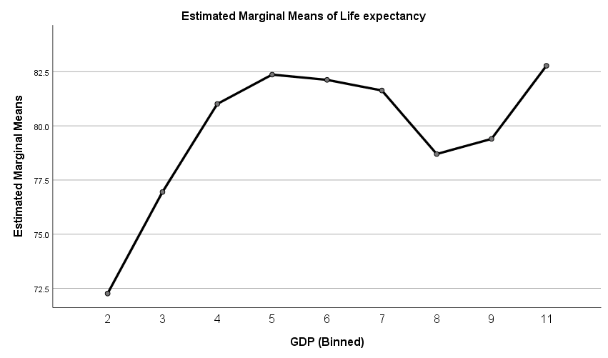

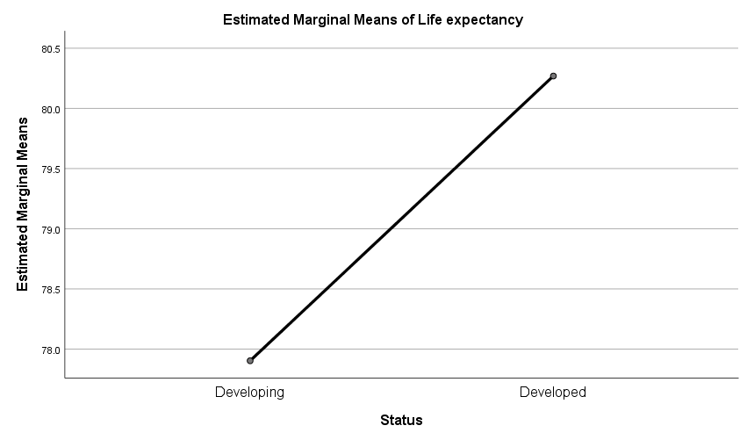

Adult Mortality

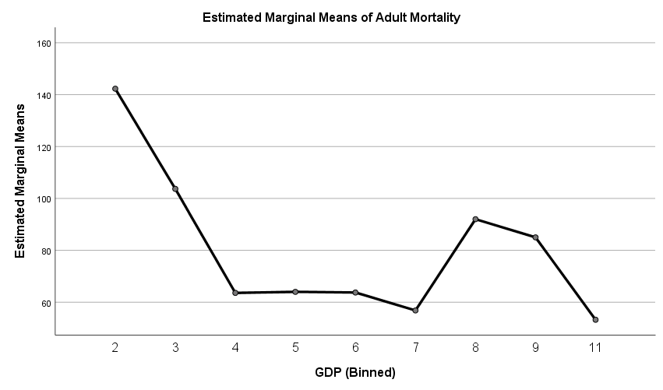

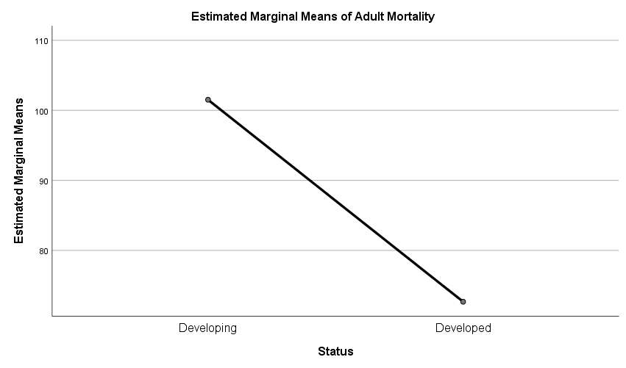

GET
FILE='C:\Users\Grace Kyendo\Desktop\Simulation & Modeling\CM_SM_QN2.sav'.

Warning # 67. Command name: GET FILE
The document is already in use by another user or process. If you make
changes to the document they may overwrite changes made by others or your
changes may be overwritten by others.
File opened C:\Users\Grace Kyendo\Desktop\Simulation & Modeling\CM_SM_QN2.sav
DATASET NAME DataSet3 WINDOW=FRONT.

